Temple Inn & Suites

Website Planning Document

Aaron Edwards

**Overview**

**Site Purpose**

**The purpose of the Temple Inn & Suites website is to promote and provide information about the specialized services that this hotel chain offers to meet the needs of temple patrons who come to serve in the temple or who participate in events; such as sealings, weddings, receptions, and youth trips. The website should reflect the LDS Church culture and be designed to support a temple-oriented theme as well as the concept of being a haven of comfort and accessibility.**

**Target Audience**

**The target audience is adults and families with young children who live far enough away from their closest temple, that it would be unreasonable to make a day trip. Or those who will stay in the area for long periods of time, but not permanent, and wish to visit the often, or everyday during their stay. These people will have low to medium income, who have no family in the area to stay with, or need special accommodations, like babysitting to make their stay comfortable and stress-free.**

## Layout

### Site Map

## Branding

**Color Palette**

<https://coolors.co/ffffff-cacfd6-0038a0-f5ffc6-2f2d2e>

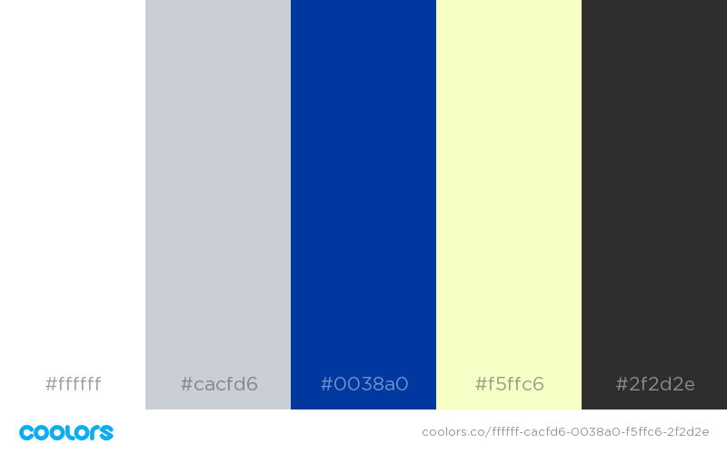

|  |  |  |  |
| --- | --- | --- | --- |
| **Primary** | **Secondary** | **Accent** | **Accent** |
| #0038a0 | #ffffff | #cacfd6 | #2f2de & #f5ffc6 |

## Typography

### Heading Font: Open Sans

### This font will be used for titles, headers and more important text. H1- h6

### “Temple Inn & Suites”

### Paragraph (Body copy) Font: Roboto

This font will be used for body and paragraphs.

Temple Inn & Suites provides essential and affordable amenities for all customers. Some of these amenities include:

* Indoor pool
* Free breakfast
* Babysitting

|  |
| --- |
|  |

## Wireframes

Small

c

Medium

Large

